Website Design Customer Brief

Customers

Describe your organization and the kind of products/services you offer as well as why they matter.

Describe the target market segments.

What needs is your target audience bringing and how do you intend to meet these needs?

Describe the major objectives for the site, as well as the activities you would like users to perform. (Eg buy a product, go to the physical store, make a donation etc)

Competition

What sets you apart from your competitors (or organizations offering similar services/products)?

Who are your competitors?

Keyword phrases. Consider the optimisation of the website for search engines (SEO). List relevant keywords.

Please outline reference websites and what you like / dislike about their sites.

Design

Outline the website menu structure, divided into main menu and sub menu items.

What overall tone will the website have?

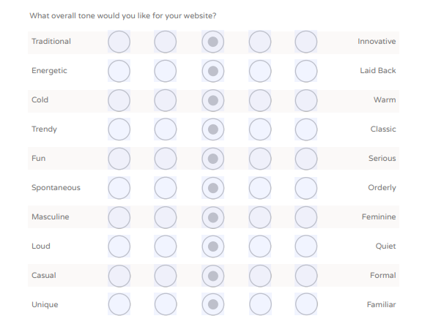

Screen shot taken from Brief example: https://moodle.unitec.ac.nz/pluginfile.php/822607/mod_resource/content/6/customer%20breif%202.pdf

Which colours?

Technical considerations

Who will be in charge of updating your website? What is their level of technical knowledge? What will you provide in terms of support for this?

Will there be training required for users or administrators of this site?

What are the hardware and software resources required (include hosting).

Will your website require other integrations? MailChimp, SalesForce etc.